

**Quinn’s Baptist College**

**MARKING KEY: Year 11 ATAR Psychology Examination**

**Structure**

|  |  |  |  |
| --- | --- | --- | --- |
|  | **Section 1** | **Section 2** | **Section 3** |
| **Time Allocated** | **Research Methods** | **Short Answer** | **Extended Answer** |
| **Marks Allocated** | **40** | **70** | **20** |

**Total /130**

**Time allowed for this paper**

Reading time before commencing work: Working time for paper:

ten minutes three hours

**Materials required/recommended for this paper**

***To be provided by the supervisor***

This Question/Answer Booklet

***To be provided by the candidate***

Standard items: pens (blue/black preferred), pencils (including coloured), sharpener, correction fluid/tape, eraser, ruler, highlighters

Special items: non-programmable calculators approved for use in the WACE examinations

**Important note to candidates**No other items may be taken into the examination room. It is **your** responsibility to ensure that you do not have any unauthorised notes or other items of a non-personal nature in the examination room. If you have any unauthorised material with you, hand it to the supervisor **before** reading any further.

**SECTION 1: RESEARCH METHODS [40 Marks]**

**QUESTION 1.**

Professor Livingston at Stanford College conducted an experiment that measured the academic benefits of taking fish oil (Omega 3) supplements. She asked for volunteers at a high school to participate in the experiment. To test his hypothesis, he divided the 20 participants into two conditions/groups. One condition was given fish oil tablets whilst the other control group was given a sugar tablet. Neither group knew which group was given the actual supplement. He used a numeracy tests to measure their academic performance. Participants wrote three different tests over a two-week period. The first test was given on day 1 before any group was given a pill; the second test was on day 5 and the 3rd on day 10. After the trial, he was disappointed to find that there was not a significant difference between the group performances on the test.

1. Write an operational hypothesis for this experiment. [2 marks]

**It is hypothesized that if 20 high school volunteers were divided into two groups, a control and experimental group, the group that were given fish oil tablets will experience greater academic success in three numeracy tests written over a two week period, than the group that were (unknowingly) given the sugar tablets.**

1. Identify the dependent and independent variables. [2 marks]

|  |
| --- |
| **DV-results or marks on numeracy tests** |
| **IV-Fish oil tablets** |

1. Use the space below to calculate **the mean** for Condition 1’s test performances on the last test: The percentage scores were: 93, 78, 66, 45, 67, 71, 89, 78, 84 and 81.

[1 mark]

|  |
| --- |
| **Mean 75.2 %** |

1. What is the **median** of this data? [1 mark]

|  |
| --- |
| 45, 66, 67, 71, **78, 78**, 81, 84, 89, 93—**Median = 78** |

1. What is the mode of this data? [1 mark]

|  |
| --- |
| **78** |

1. Identify the term that refers to the substance given to the control group that has no known medical effect. [1 mark]

|  |
| --- |
| **Placebo** |

1. Explain what could have influenced the control group to improve in the same way that experimental group improved on the numeracy test. [1 marks]

|  |
| --- |
| **Placebo effect: The participants’ scores on the numeracy test could have been influenced by their *expectations/* of how they should behave, caused by the belief that were taking the Omega 3 supplements.** |

1. Identify a procedure that could have been implemented to avoid the invalid conclusions.

[ 1 mark]

|  |
| --- |
| **Single-blind procedure where the participants were told they were in the control or experimental group** |

1. Outline **two** pieces of information about a research study that a researcher must provide to participants so that they can give **informed consent.** [2 mark]

|  |
| --- |
| **Purpose of the study** |
| **What supplements they are given (information regarding expectations etc)** |

1. Explain what professor Livingston should do after the experiment has ended to ensure that the study was conducted ethically. [1 mark]

|  |
| --- |
| **Debrief the participants and explain which group they were in and what findings the experiment yielded.** |

**Question 2.**

A research study was conducted to examine the effects of alcohol consumption on feelings of sadness. Fifty adult participants were randomly assigned to either Group A or Group B.

Participants were individually engaged in the following sequence of tasks:

* Complete a mood rating scale
* Discuss with the researcher three recent times when they felt sad; the purpose of this was to induce a state of sadness in the participant
* Complete the mood rating scale a second time
* Drink a moderate amount of ‘alcohol’ over a 20 minute period
* Wait 20 minutes for the ‘alcohol’ to be absorbed by the body

All participants were told that they would be given a moderate amount of alcohol to drink. Participants assigned to Group A were given an alcoholic drink. Participants assigned to Group B were given a non-alcoholic drink that appeared to be an alcoholic drink.

1. State a hypothesis the researcher could have developed for this study. [1 mark]

**It is hypothesized that if 50 adult volunteers were divided into two groups, a control and experimental group, the group that were given a moderate amount of alcohol over a 20 minute period will experience greater feelings of sadness (measured by a mood rating scale) than the group that were (unknowingly) given the non-alcoholic drink.**

1. Identify:
2. the independent variable for this study [1 mark]

**The alcohol and non-alcoholic drinks**

1. the dependent variable for this study [1 mark]

**The mood or feelings of sadness experienced by each group.**

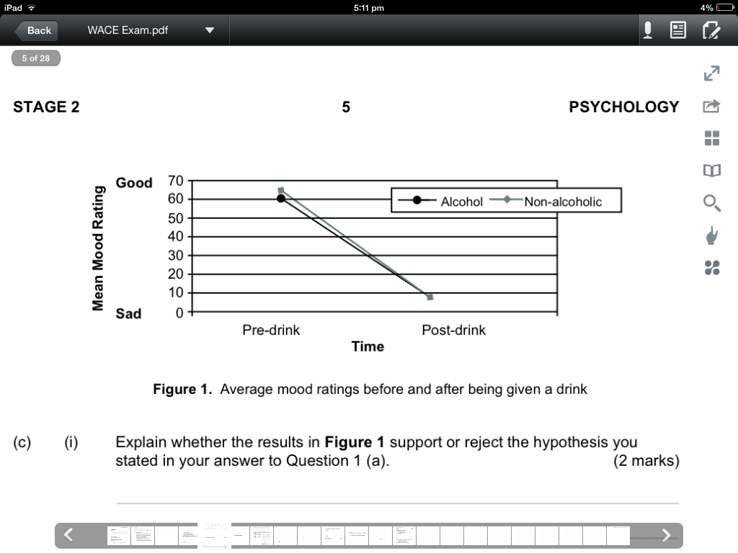

1. (i) **Explain** whether the results in **figure 1** support or reject the hypothesis you stated in your answer to Question 1 (a). [2 marks]

**The results in fig. 1 reject the hypothesis that those who drank alcohol would experience greater degree of sadness compared to those who drank the placebo drink.**

1. **Identify** **one** limitation of this study [2 marks]

**Placebo effect may have had exactly the same impact on participant’s moods?**

**Question 3. Define** what is meant by the **variance** of a distribution of scores on a psychological test.

[2 marks]

_______________________________________________________

1. What does a **variance of zero** indicate about a distribution of test scores? [1 mark]

_______________________________________________________

1. **Explain** how test scores are distributed in a normal curve. [2 marks]

**Question 4.**

A research study was designed to investigate the extent to which children and adolescents associate tattooed individuals with antisocial (or negative) behaviours.

Data was collected using a task presented as a 20 page picture booklet entitled “Who is it?” Each page of the booklet showed a picture of three different men, one of whom was tattooed.

Below each set of pictures was a statement about the recent behaviour of one of the men. This was followed by the question ‘Who is it?’ Students were asked to tick the picture of the person whom they thought best matched the statement.

One third of the statements below each picture referred to positive (or pro social) behaviour, one third to anti-social behaviour and one third to neutral behaviour.

The researchers were interested in how often children associated positive (or pro social), negative (or anti-social), or neutral behaviour with the man with tattoos.

Scores were tallied for each type of association by scoring ‘1’ every time the students ticked the picture of the tattooed man, and ‘0’ when either of the other pictures was ticked. For each participant, this provided three stereotype scores (positive, neutral and negative choices), each with a possible range from 0 to 6. Mean scores for each age group studied are summarised in **Table 1** below.

**Table 1**. Mean stereotype scores by age

|  |  |  |  |
| --- | --- | --- | --- |
| **Age** | **Positive** | **Neutral** | **Negative** |
| **6 Years** | 2.24 | 1.50 | 3.17 |
| **8 Years** | 1.86 | 1.14 | 3.91 |
| **10 Years** | 1.17 | 1.23 | 4.27 |
| **12 Years** | 1.40 | 1.32 | 4.25 |
| **14 Years** | 1.44 | 1.33 | 3.84 |
| **16 Years** | 1.46 | 1.52 | 3.73 |

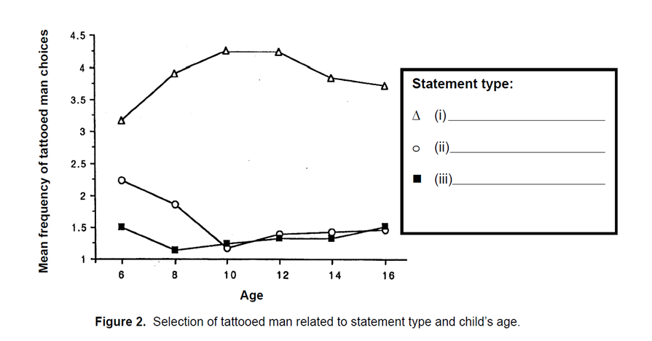

1. Consider the data in **Table 1** and the line graphs in **Figure 2** above. Use this information to correctly label the **‘Statement type’** for each line graph in figure 2 as positive, neutral or negative. [3 marks]
2. Name **two** variables other than gender that could have influenced student responses if researchers had not controlled for them. [2 marks]

Variable one: _________________________________________________________

Variable two: _________________________________________________________

1. Look at the trends in **Table 1 and Figure 2.** **Describe** what these findings suggest about the extent to which the children and adolescents in the study associated tattooed individuals with antisocial behaviours. [3 marks]

____________________________________________________________________________________________________________________________________________________________________________________________________________________________________________________________________________________________________________________________________________________________________________________

**Question 5.**

Dr. Rebecca Arrow wanted to examine the validity of Charles Spearman’s theories. She observed that scores on various different tests such as mathematics and memory were correlated highly with one another. Unlike Spearman, she found that even though mathematics and memory scores were highly related; that the scores on language tests were only slightly related to mathematics; and that scores examining bodily kinesthetic coordination had no correlation to the performances in mathematic tests. She displayed the correlational data on three separate graphs below.

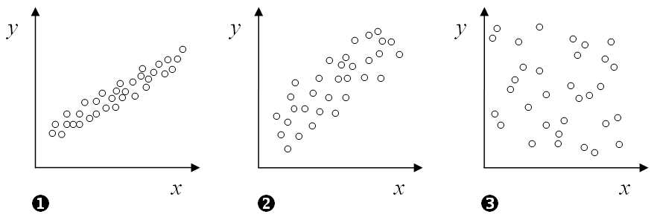

1. What are some benefits of displaying data on graphs? [2 marks]

|  |
| --- |
| **Graphs can show another way of representing data, which makes it easier to analyze and summarize.** |

1. How would you describe the relationship for Graph 1? [1 mark]

|  |
| --- |
| **It is a strong positive relationship (correlation)** |

1. Identify which graph belonged to which of the following correlations (by writing the number in the space provided): [3 marks]

* Coordination and mathematics. Graph **____________ 3**
* Mathematics and memory. Graph **_____________ 1**
* Language and mathematics. Graph **________________ 2**

1. Which of the following correlation coefficients would fit each of the graphs; [3 marks]

* r = .25

**Graph 3**

* r = .5

**Graph 2**

* r = .7

**Graph 1**

1. Nevertheless like Spearman, Dr. Arrow concluded that correlations between various abilities were positive but modest. What term did Spearman give to the fact that different tests measured the same factor of mental intellect? [ 1 mark]

|  |
| --- |
| **General intelligence** |

**SECTION 2: Short Answer [70 marks]**

**Question 5**: Define the following terms: [5 marks]

|  |  |
| --- | --- |
| Perception | **Organizing and interpreting what sense organs take in.** |
| Habituation | **Learning not to respond to events or activities that occur repeatedly or do not grab your attention.** |
| Divided Attention | **Attending to and undertaking two different activities simultaneously.** |
| Placebo effect | **The positive influence a belief in the power of a (an inactive) substance or (useless) procedure administered to patients, unaware that it is fake, has on those patients.** |
| Active listening | **Listening carefully and giving full attention to the speaker, constantly trying to understand what the speaker is thinking, feeling or wanting before responding.** |

**Question 6:** Describe the different stages of Dexter Dunphy’s adolescent groups.

|  |
| --- |
| **Stage 1—form cliques (same sex, isolated groups)**  **4-10 members meet to plan social activities, share secrets and gossip.**  **Stage 2—crowds form when unisex cliques interact**  **Seen through ‘safety in numbers’ that enables social interaction and bantering between cliques.**  **Stage 3—structured crowd: higher ranking clique members form heterosexual cliques and start dating.**  **Stage 4—fully developed crowd with a number of couples in close association**  **Stage 5—Disintegration of crowd: Couples go separate ways** |

**Question 7.** Why do psychologists have to be specially trained to use individual intelligence tests? [1 Mark]

|  |
| --- |
| **Complex testing procedures with standardized measures that have to be followed exactly** |

**Question 8.** What do we mean by cultural bias in tests? [2 marks]

|  |
| --- |
| **Questions and tasks in most tests are developed by white educated middle class psychologists that reflect the types of things taught in school: general knowledge, word meanings and mathematics.** |
| **Negative bias towards minority groups who have not had the same education or life experiences.** |

**Question 9:** Dr. Charles Brook, a psychologist, has been hired by an advertising company to help them recruit more ‘intelligent’ employees. His first objective is to prepare a presentation on the importance of ‘emotional intelligence’ in the workplace. Briefly discuss the theory behind emotional intelligence and explain what evidence is there to suggest it is required for the workplace. [2 marks]

|  |
| --- |
| **Daniel Goleman defined Emotional intelligence as “social competence and interpersonal skills and it aids effective social interaction with others” [1 mark].**  **People with high EQ can be regarded as having superior interpersonal skills that may be useful for social situations and work [1 mark].**  **OR**  **Thus the workplace relies on people’s ability do work effectively with other people, to communicate important information, interpret nonverbal cues, deal respectfully with colleagues and resolve conflict.** |

**Question 10.** Which part of the brain plays a role in self-control the expression of personality? Discuss the situation that led to this discovery? [3 marks]

|  |
| --- |
| **Frontal lobe [1 mark] due to the Phineas Gage’s famous case [1 mark]. His accident caused a rod to cause severe damage to his frontal lobe. He went from a polite, hard-working pleasant man, to one that was loud, impulsive, moody and dishonest.** |

**Question 11.** Compare and Contrast a MRI and PET scan. [4 marks]

|  |
| --- |
| * **MRI (Magnetic Resonance Imaging) scan uses magnetic field to produce a 3D picture of the brain [1] and can detect abnormalities. [1]** * **A PET (Positron Emissions Tomography) displays the sugar consumption of the brain. [1] This shows the parts of the brain that uses more energy. [1]** |

**Question 12. .** How did David Wechsler define intelligence? And what was Howard Gardner’s description of intelligence? [4 marks]

|  |
| --- |
| * **DW defined intelligence as ‘The aggregate or global capacity to act purposefully, think rationally and deal effectively with the environment.’** * **HG argued that intelligence is more than able to solve problems, he proposed that instead of one general intelligence, each of us has seven different kinds of intelligence. Multiple Intelligences.** |

**Question 13.** **.** **Briefly identify** each of the FOUR physiological responses indicating different states of consciousness. Provide a brief explanation for each one [8 marks]

|  |
| --- |
| **Brain waves: The Brain’s electrical activity is at its highest during normal waking consciousness; Brainwave patterns measured in terms of the number of waves per second (frequency) and size of peaks & troughs (amplitude) on an (EEG) electroencephalogram** |
| **Heart rate: Changes in our heart rate accompany changes in our level of awareness. Slows down during sleep. Measured by taking pulse rate or heart monitor.** |
| **Body Temperature: Changes with changes in consciousness; drops slightly (by more than 1 degree C) during sleep.** |
| **Electrical conductivity of the skin: Measured by attaching electrodes to fingers or palms. Sweat… Galvanic Skin Response (GSR) indicates our**  **level of arousal** |

**Question 14.** Describe TWO the biological benefits of exercise. [2 marks]

|  |
| --- |
| **Strengthens the heart, *increasing blood flow and lowering blood pressure and the blood pressure reaction to stress*** |
| **Reduces depression: It increases the production of mood-boosting neurotransmitters such as: norepinephrine, serotonin and the endorphins.** |
| **Increases energy—tired less often** |

**Question 15**. Cathy drinks a lot of coffee. Explain in detail the way in this particular drug affects her nervous system. [2 marks]

|  |
| --- |
| **Stimulant (uppers) [1 mark] affects the sympathetic nervous system; arouses body functions [1 mark]** |
| **Increase heart rate and breathing rates; Appetite decreases because blood sugar rises, energy & self-confidence get a boost. [1 mark]** |

**Question 16.** Discuss three different states of consciousness [3 marks]

|  |
| --- |
| **Total awareness** any 3 discussed  **Selective Attention**  **Divided Attention**  **Daydreaming**  **Meditative States**  **Hypnotised**  **Asleep**  **Anaesthestised**  **Unconscious**  **Complete lack of awareness** |

**Question 17.** **Explain** how mental age and IQ (Intelligence Quotient) are measured and name the Theorists involved with the creation of this process [4 mark]

**The Stanford-Binet Scale introduced the idea of the intelligence quotient (IQ score), which was calculated by dividing mental age by chronological age and multiplying by 100. In this way an adolescent of 15 years with a mental age of 15 years would have an IQ of 100- average IQ score. [3 marks]**

**Theorists: Alfred Binet & Theodore Simon and Lewis Terman & colleagues at Stanford University**

**Question 18.** Alison loves helping people. She finds fulfillment especially in volunteering at homeless shelters. Explain whether her behaviour demonstrates pro-social or altruistic behaviour. Give reasons for your answer. [2 marks]

|  |
| --- |
| **Prosocial behaviour generally describes any helping behaviour or acts of kindness, whereas altruistic behaviour refers to behaviour that is undertaken without any regard to own health, welfare or safety.** |

**Question 19**. Evaluate the three main theories of attraction. [3 marks]

|  |
| --- |
| **Balance Theory: We like people who are similar to ourselves because they affirm our own views and attitudes.**  **Reinforcement Theory: We like people who are present when we receive a reward even when they have nothing to do with that reward.**  **Social Exchange Theory: Whether we like someone is determined by the cost-benefit ratio, which states ‘What do I need to do or what will it cost me, to get a positive reward from the other person?** |

Question 20. Use ONE determination of liking to discuss how friendship can break down. [1 mark]

|  |
| --- |
| **Proximity—friendships break down without contact or when expectation of continued social interaction is not met.** |
| **Similarity—when too much dissimilarity in views exists that friendship is difficult to maintain.** |

Question 21. A. Using an example, explain the term **‘reciprocity’.**  [2 marks]

|  |
| --- |
| **Definition: We are more likely to help people and to like them if they have helped us in the past.** |
| **Example: Lending money to someone who previously lent money to you** |

B. Using an example, explain the term **‘Pro-social behaviour’.** [2 marks]

|  |
| --- |
| Definition: **Prosocial behaviour generally describes any helping behaviour or acts of kindness, whereas altruistic behaviour refers to behaviour that is undertaken without any regard to own health, welfare or safety.** |
|  |
| **Example: Helping someone after an accident or help in charity organization etc** |

Question 22. Howard Gardner included ‘kinesthetic intelligence’ as one of his categories of Multiple Intelligence. **Describe** kinesthetic intelligence and give an example. [2 marks]

|  |
| --- |
| **Use of body or its parts to solve problems. Great coordination.** |
| **Example: Talented sportsmen** |

**Question 23**. Using empirical evidence, give two examples how physical activity (exercise) can affect our wellbeing. [2 marks]

|  |
| --- |
| **McCann & Holmes study on female college students who were split into 3 groups, found those who did exercise improved their overall depression score. Field’s found that those students who did regular exercise had better grades, better relationships with their parents and were less depressed. Myer’s found those that did exercise had an increase in serotonin (mood booster) and lower blood pressure.** |

Question 24. Describe the differences between a dyad, clique and crowd.

**Dyad—A pair of close friends or lovers**

**Clique—A small close group of people (4-10) who have shared values and interests.**

**Crowd—Loosely organised group of several cliques that share values**

**Question** **25**. Use the diagram and table below to label and describe the functions of the following parts of the brain: Hindbrain, Forebrain and Midbrain. [6 marks]

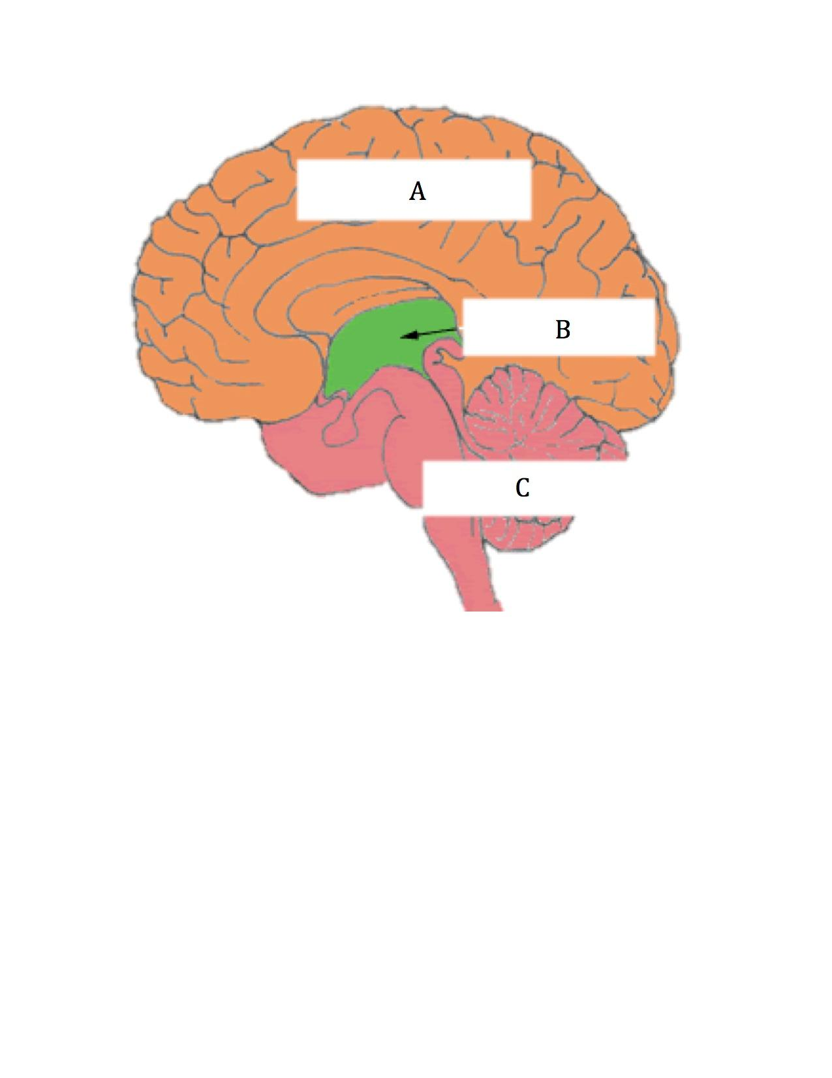

|  |  |
| --- | --- |
| Brain Area | Function |
| A) **Forebrain** | **Higher brain functioning activities: controls how we think feel and behave.** |
| B) **Midbrain** | **Receives messages from our senses (not smell) and sends messages to other parts of the brain.** |
| C) **Hindbrain** | **Controls activities that are not under conscious control e.g. breathing** |

**Question 26**. What is the function of the Corpus Callosum?

|  |
| --- |
| **Connects the two hemispheres together and relays messages between hemispheres.** |

SECTION 3

Extended Answer: [15 marks]

Discuss communication under the headings of:

* Non-verbal communication
* components of language
* language characteristics
* Robinson’s social skills